MEMORANDUM OF UNDERSTANDING

Parties: Henry Harvin and Entrepreneurship Cell (E-Cell) of Manipal University Jaipur (MUJ) Date of agreement: 21/1/2023

The objective of the Memorandum of Understanding:

Henry Harvin is willing to conduct a workshop for the students of MUJ. As per the negotiations held between the two parties, the following points were mutually agreed upon:

Henry Harvin deliverables:

- Provide the mailers, WhatsApp content, Registration Link, posters, Google Form, etc. for promotion
- Provide a 7% Monetary Stipend from the Total revenue generated through the promotion done by the Committee/Club
- Free access to the selected course for 2 Members
- Provide certificates for the list of students who registered
- Early access to the LMS Portal, with access to other campus videos and course-related materials
- 9 in 1 Feature
  - Training Course: Instructor-led training + Case Studies
  - Hallmark Certification: Globally recognized Certification
  - Live Projects: Hands-on 10+ Projects
  - Guaranteed Internship: 1-3 Months domain-specific internship Click Here
  - Off-Campus Placement Support: Access to Henry Harvin JobsForYou Portal
  - Hackathons: Participate in #AskHenry leading competitions
  - Bootcamps: 12+ Career Bootcamps Sessions
  - E-Learning: Recorded Videos, PPTs, Case Studies, 24X7 Support
  - 1 Yr Gold Membership: Access to Henry Harvin Analytics Academy

Entrepreneurship Cell (E-Cell) of MUJ, Deliverables

- Sharing promotional and Registration Link Via WhatsApp groups, E-Mails, and Social media platforms to All Campus Students at least 4 times on each platform whenever asked by Henry Harvin RM
- Generate Interest in Google Forms and help convert those interests into registrations

Bank details:
Name: HENRY HARVIN INDIA EDUCATION LLP
Account NO: 004605019001
IFSC Code: ICIC0000046
Bank Name: ICICI BANK,
Branch: N.F.C NEW DELHI,
Swift Code: ICICINBBCTS

Term of MOU
This MOU shall come into force from the date of signing and shall remain valid for a period of 1 Year from the Date of Signing and can be extended for a period of one year taking into consideration the mutual consent of both parties, unless and otherwise terminated by either party as mentioned in

Miscellaneous:

This MoU supersedes all prior understandings, if any, between parties concerning the subject hereof. All amendments to the MoU shall be valid if executed in writing and signed by both parties.

Name: Siya Mulge Name: Kounal Gupta

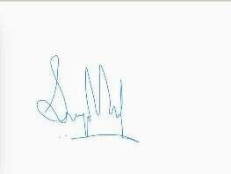
Designation: Chairperson, E-cell MUJ Designation: CEO

Signature: Signature:

Signature Certificate
Reference number: 8GCBA-LJGRV-ZKHAR-NCBFX

Signer Timestamp Signature

Kounal Gupta
Email: kounal@henryharvin.com
Shared via link

Sent: 10 Feb 2023 13:33:40 UTC
Viewed: 10 Feb 2023 15:19:31 UTC
Signed: 10 Feb 2023 15:20:00 UTC

IP address: 106.210.45.224
Location: Delhi, India

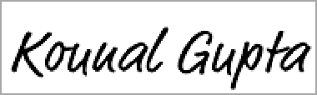

Document completed by all parties on: 10 Feb 2023 15:20:00 UTC

Page 1 of 1

Signed with PandaDoc

PandaDoc is a document workflow and certified eSignature solution trusted by 40,000+ companies worldwide.

